Ideation Phase

The Problem Statement

|  |  |
| --- | --- |
| Date | 15 October 2022 |
| Team ID | PNT2022TMID43983 |
| Project Name | PLASMA DONOR APPLICATION |
| Maximum Marks | 2 Marks |

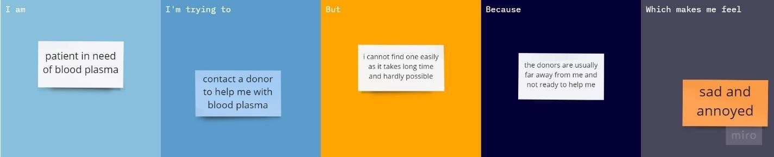

|  |  |  |  |  |  |
| --- | --- | --- | --- | --- | --- |
| **Problem**  **Statement (PS)** | **I am (Customer)** | **I’m trying to** | **But** | **Because** | **Which makes me feel** |
| PS-1 | A patient in need of blood plasma | Contact a donor to help me with blood plasma | I cannot find one easily as it takes long time  and hardly possible | The donors are usually far away form me  and not ready to help me | Sad and annoyed |
| PS-2 | Hospital management | Get donors for the patient to donate plasma | I have limited donors and also they are not available now | They are all busy on their works | Pity for the patients |